**Introduction to HTML**

**HTML. How do I code in HTML? (When in doubt, ask Google):**

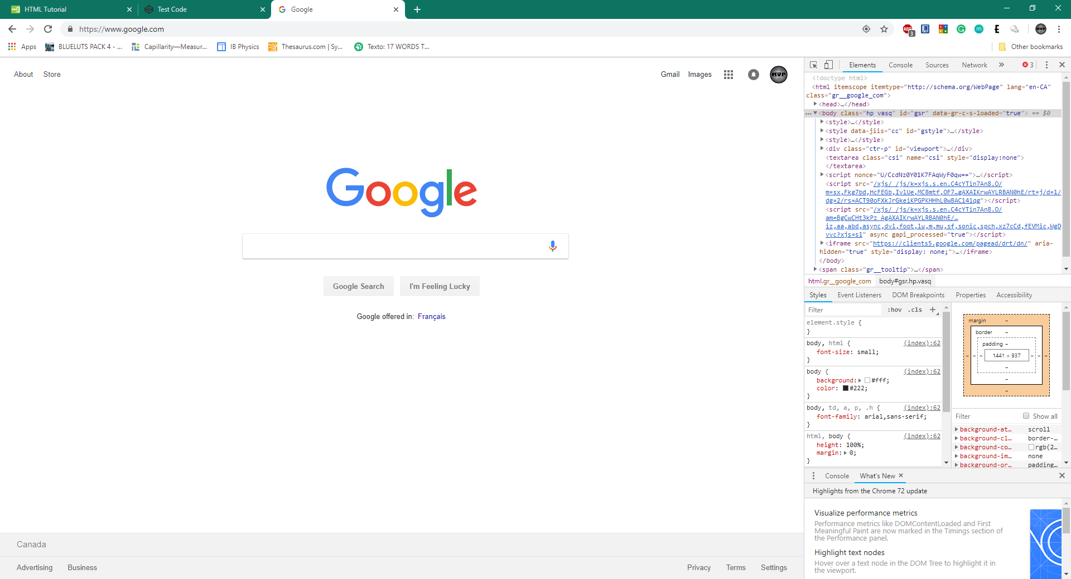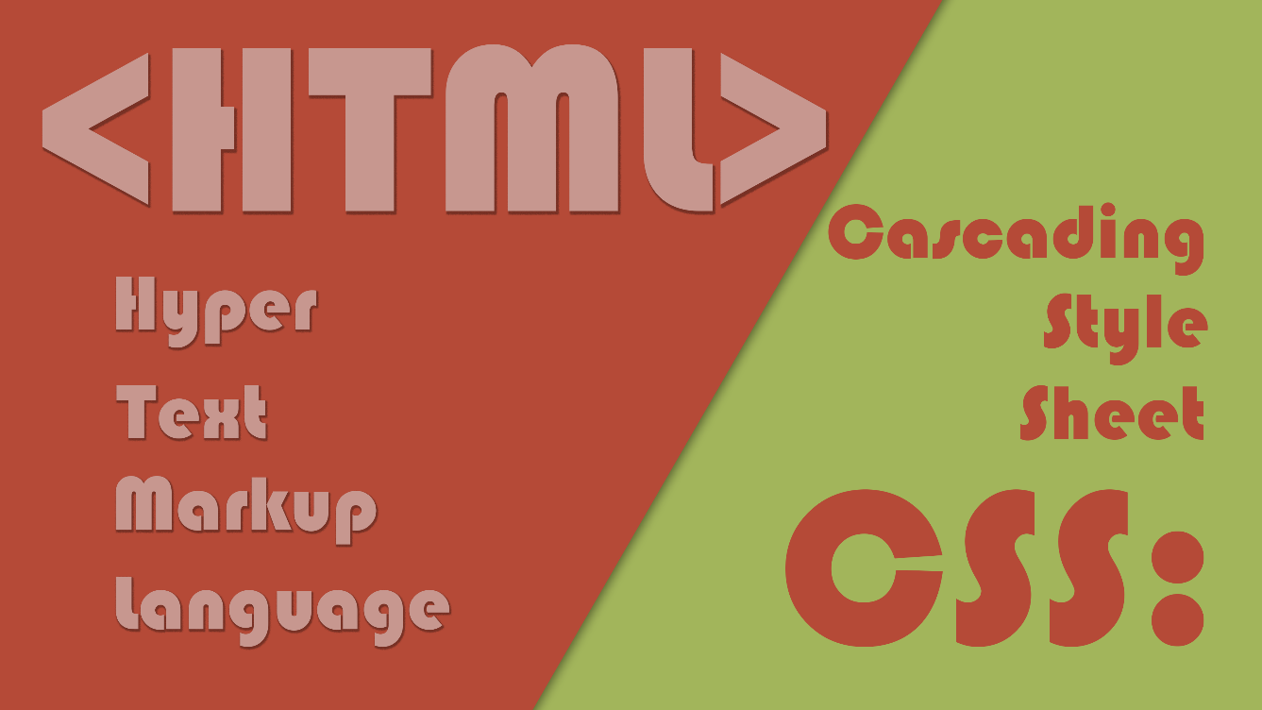

**HTML forms up most of the internet, as every website consists mainly of HTML and CSS which are languages used to form the basic outline of the website and to incorporate context.**

Most modern websites is consisted of HTML5 and CSS which works together with JavaScript and server-based PHP to make the interactive parts of the website. Designing in HTML helps minimize the tasks needed to be completed by the client’s processor since it is based around a design environment instead of a graphics-based system such as JavaScript. However, JavaScript will eventually be needed to incorporate for the more interactive parts of the website such as games and animated elements.

**HTML Elements:**

HTML tags are element names surrounded by angle brackets.

<tagname>content goes here...</tagname>

* Usually appearing in pairs.
* Consisting of a start tag and an end tag.
* End tag is identical to start tag except with a forward slash inserted before the start tag.

HTML elements5 can be nested for one element to be inside of another element.

**Different types of tags:**

**HTML Tag and Declaration:**

<!DOCTYPE html><!-- THIS IS NOT NEEDED FOR HTML5 -->

<html><!--HTML DECLARATION TAG-->

<head><!--META DATA Information-->

<title>**Time to HTML**</title><!--Title Delaration-->

<link href=**"element.css"** rel=**"stylesheet"** type=**"text/css"**><!--Linking to CSS File-->

<link rel=**"shortcut icon"** type=**"image/png"** href=**"img/favicon.png"**><!--Favicon-->

</head>

<body><!--Main Content Element-->

<div style=**"border: red 2px solid"**><!--Creates an Container Element-->

<h1 style=**"text-align: center"**>**CODING HTML**</h1><!--Heading Element h1 to h6-->

<p>**CONTENT FOR DOCUMENT**</p><!--Paragraph Element-->

<a href=**"https://wos.hdsb.ca/"**>**Click here for more info**</a><!--Linking-->

</div>

<!-- CONTENT HERE IN BODY -->

</body>

</html>

**<html>** This element is used to declare to the document that this is the start of the HTML code for this document.

**<head>** This element marks metadata of the document, which are information that are not visually displayed to the user. Including but not limited to linking other documents, providing the title of the document (page name)

**<link>** Used for connecting code or connecting resources used for the website.

**<body>** Element containing the main content belonging to the document.

**<div>** Simple container used for information or organized nesting.

**<h1>** Heading texts, used to format the headings of the document, ranging from h1 to h6.

**<p>** Paragraph containers, used to contain large amounts of information to be displayed.

**<a>** Linking container, leads the user to a designated website.

**Style=”<!—CONTENT HERE**-->” Style attribute of the current element.

**Practice Questions:**

1. **(EASY) Simple Website from the 90s**

Create a website with a heading and a paragraph, with a blue 2px wide solid border surrounding the texts. Additionally, make sure the website’s main header is centered and colored blue. While you are coding, why don’t you add a link to our favorite web development website, https://www.w3schools.com/?

1. **(MEDIUM) Modernizing**

With what you have accomplished in the first question, add a favicon on to the tab and a title to tell the audience what this page is about just by the tab. Find an image you like and make it the favicon of your website! Make sure the file of the image is small enough to be efficient in loading, do not keep the customers waiting!

**Challenge Question:**

1. **Video Background**

Now you have all the information you are trying to deliver, why don’t we add some spice to our website? Videos do not seem like that bad of an idea! Try to add a video background to your website! (Hint: <source>, <video>)

**Resources:**

<https://www.w3schools.com/> (Web Development Website)

<https://www.w3schools.com/html/html_basic.asp> (Essential Basics)

<https://www.w3schools.com/html/html_elements.asp> (Information on Elements)